Используя SQL языки произвольные две таблицы из модели данных необходимо объединить их различными способами (UNION, JOIN)

select ticket_no,

flight_id :: text,

fare_conditions

from bookings.ticket_flights

union

select ticket_no,

passenger_id :: text,

passenger_name

from bookings.tickets

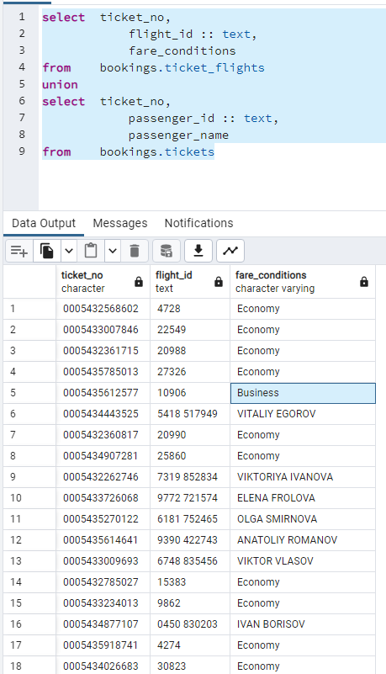

select bookings.ticket_flights.*,

tickets.book_ref,

passenger_id,

passenger_name,

contact_data

from bookings.ticket_flights

inner join bookings.tickets

on bookings.tickets.ticket_no = bookings.ticket_flights.ticket_no

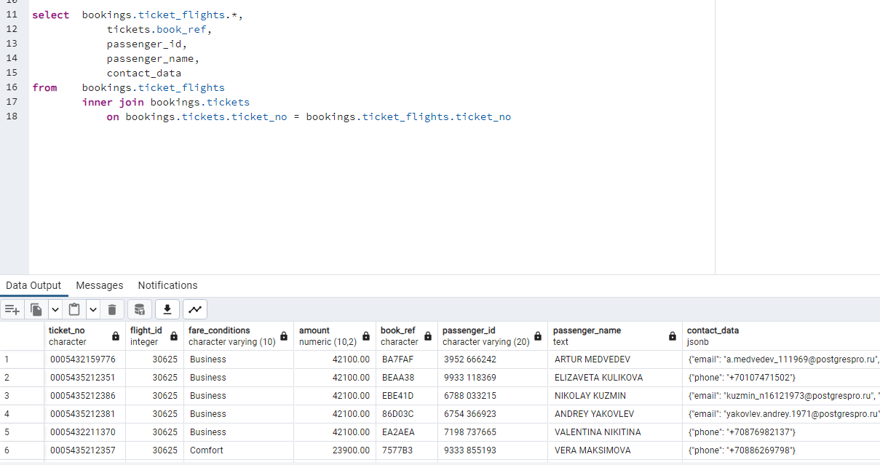

Используя SQL язык напишите запрос с любым фильтром WHERE к произвольной таблице и результат отсортируйте (ORDER BY) с ограничением вывода по количеству строк (LIMIT)

select ticket_no,

flight_id,

fare_conditions,

amount

from bookings.ticket_flights

where fare_conditions = 'Economy'

order by ticket_no,

flight_id,

amount

limit 100

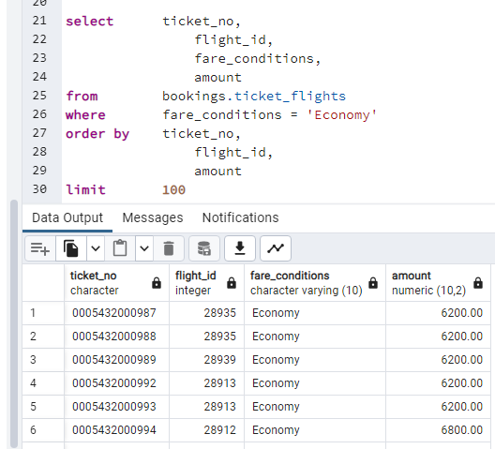

Используя SQL язык напишите OLAP запрос к произвольной связке таблиц (в рамках JOIN оператора), используя оператор GROUP BY и любые агрегатные функции count, min, max, sum.

select flight_no,

fare_conditions,

min(amount),

max(amount)

from bookings.ticket_flights

inner join

bookings.flights

on bookings.ticket_flights.flight_id = bookings.flights.flight_id

group by fare_conditions,

flight_no

order by flight_no

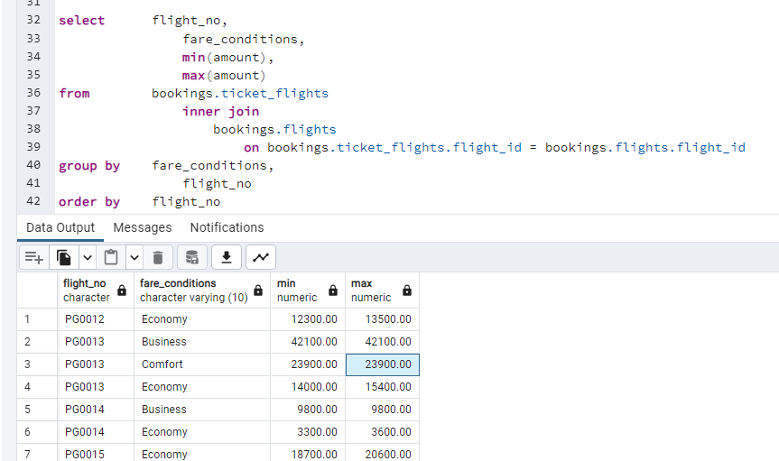

select flight_no,

scheduled_departure,

scheduled_arrival,

departure_airport,

arrival_airport,

count(bookings.boarding_passes.ticket_no),

sum(amount)

from bookings.flights

inner join

bookings.boarding_passes

on bookings.flights.flight_id = bookings.boarding_passes.flight_id

inner join

bookings.ticket_flights

on bookings.ticket_flights.flight_id = bookings.flights.flight_id

and bookings.ticket_flights.ticket_no = bookings.boarding_passes.ticket_no

group by flight_no,

departure_airport,

arrival_airport,

scheduled_departure,

scheduled_arrival

order by flight_no

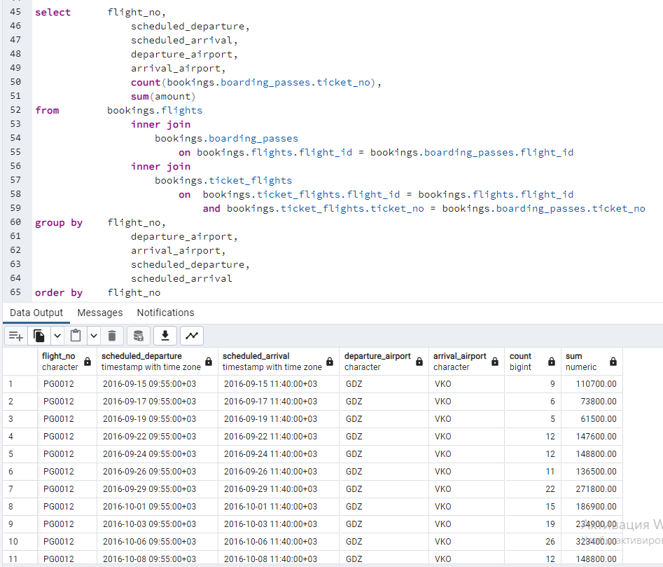

select distinct

bookings.aircrafts.aircraft_code,

model,

arrival_airport

from bookings.aircrafts

left join bookings.flights

on bookings.flights.aircraft_code = bookings.aircrafts.aircraft_code

left join bookings.airports

on bookings.airports.airport_code = arrival_airport

order by aircraft_code,

arrival_airport

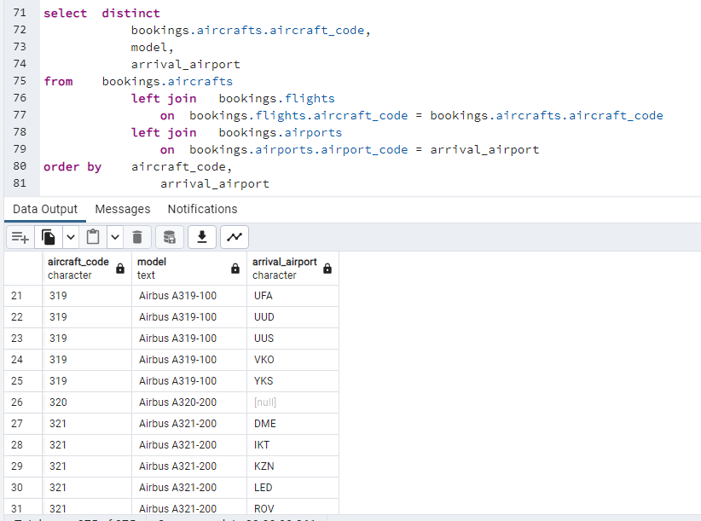

create view bookings.V_bookings

as

select ticket_no,

flight_id,

fare_conditions,

amount

from bookings.ticket_flights

where fare_conditions = 'Economy'

order by ticket_no,

flight_id,

amount

limit 100

select *

from bookings.V_bookings

Используя язык программирования Python, создайте Python-скрипт для вывода данных на экран (в консоль или IDE) из задания 5)

